Send Email Program Specifications for ABC Asset Management Fund Fact Sheet Generator
Project ID
Project Name | ABC Asset Management Fund Fact Sheet Generator
Account
Business Unit / Global Account
Project Manager
Document Version Number | 1.0.0
Approved by:

Revision History
Version Number | Release Date | Description of Change/s made | Author  (Name & Role) | Reviewer  (Name & Role) | Approver  (Name & Role)
 | Mmm-DD-YY

Table of Contents
Revision History 2
1. Program Description 4
1.1 Unit Name, Version and Language used 4
1.2 Unit Description 4
2. Input Specifications 4
2.1 Files/Tables 4
2.2 Screen Layouts 4
2.3 Parameters Passed 4
2.4 Validations 4
3. Process Specifications 4
3.1 Program structure chart 4
3.2 Pseudo code 4
4. Output Specification 5
4.1 Files/Tables 5
4.2 Screen Layouts 5
4.3 Report Layouts 5
4.4 Parameters Passed 5
4.5 Output formatting 5
5. Performance 5
6. Security 5
7. Reuse or Third-party component 6

Program Description

Unit Name, Version and Language used

Unit Name: Send Email
Language used: C#

Unit Description

The program unit is an automated process that send emails to relevant investors.

Input Specifications

Files/Tables

companyInfo
Field Name | Data type | Size | Constraints | Remarks
fundTicker | Varchar | 50 | Primary Key
ISIN | Varchar | 50 | Foreign Key
status | Varchar | 50
companyName | Varchar | 50
sector | Varchar | 50
fixedHoldingRatio | Decimal | 18,0

fundDetails
Field Name | Data type | Size | Constraints | Remarks
ISIN | Varchar | 50 | Primary Key
UID | Varchar | 50 | Foreign Key
levy | Varchar | 50
benchmarkName | Varchar | 50
benchmarkTicker | Varchar | 50
fundManagerName | Varchar | 50
fundSize | Decimal | 18,0
baseCurrency | Varchar | 50
noOfHolding | Int
initialFee | Int
EIS | Varchar | 50
AIS | Decimal | 18,0
TER | Decimal | 18,0
unitNAV | Decimal | 18,0
inceptionDate | Date
dividend | Varchar | 50
bloombergTicker | Varchar | 50

email
Field Name | Data type | Size | Constraints | Remarks
email | Varchar | 50 | Primary Key
ISIN | Varchar | 50 | Foreign Key

dailyFund
Field Name | Data type | Size | Constraints | Remarks
date | Date |  | Primary Key | Composite
fundTicker | Varchar | 50 | Primary Key | Composite
ISIN | Varchar | 50 | Foreign Key
price | Decimal | 18,0
share | Decimal | 18,0

main
Field Name | Data type | Size | Constraints | Remarks
date | Date |  | Primary Key | Composite
ISIN | Varchar | 50 | Primary Key | Composite
NAV | Decimal | 18,2 | Foreign Key
offer | Decimal | 18,2
benchmarkPrice | Decimal | 18,2

Screen Layouts

Parameters Passed
- Date
- NAV
- Levy
- BenchmarkPrice
- companyName
- sector
- benchmarkName
- fundManagerName
- fundSize
- baseCurrency
- noOfHolding
- initialFee
- EIS
- AIS
- TER
- unitNAV
- inceptionDate
- dividend
- bloombergTicker
- email

Validations.

Process Specifications

Program structure chart
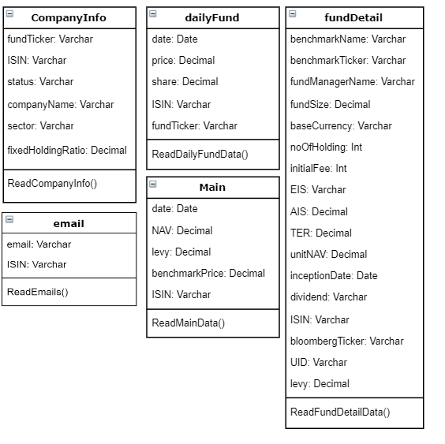

Pseudo code

ReadCompanyInfo{
Open SQL connection
Retrieve companyName and sector
Close SQL connection
}
ReadDailyFundData{
Open SQl connection
Retrieve date, price and share
Close SQL connection
}
ReadMainData{
Open SQL connection
Retrieve NAV, levy, benchmark for year-to-date, 1 month, 3 month, 6 month, 1 year and since inception.
Close SQL connection
}
ReadFundDetailsData{
Open SQL connection
Retrieve benchmarkName, fundManagerName, fundSize, baseCurrency, noOfHolding, initialFee, EIS, AIS, TER, unitNAV, inceptionDate, dividend and bloombergTicker.
Close SQL connection
}
ReadEmails{
Open SQL Connection
Retrieve investorlist
Foreach investor in investorlist
Email fund fact sheet.pdf
Close SQL Connection
}

Output Specification

Files/Tables

Screen Layouts

Report Layouts
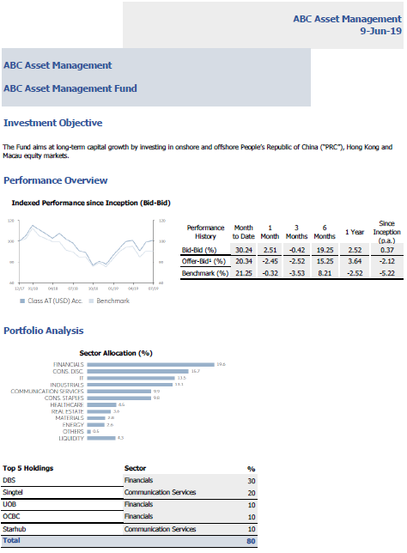
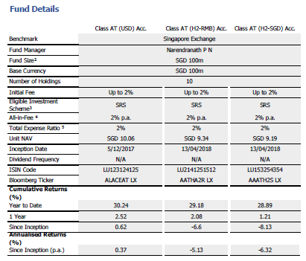

Parameters Passed

Output formatting

Performance
Performance Requirements | Design | Constraints

Security

Application Areas | Identify special transactions and areas requiring Encryption
Application Data | Identify data that requires Encryption
Encryption in Transit/Storage | Identify need for Encryption while data transfer or storage
Encryption Policy | State the policy that governs Encryption

Reuse or Third-party component

External component | Module impacted | Assumptions and Constraints | Source/License

Template Revision History (For EPEX Use Only)
Version Number | Release Date | Description of Change/s made | Author  (Name & Role) | Reviewer  (Name & Role) | Approver  (Name & Role) | QMS Release Version
1.0 | NA | Initial baseline | NA | NA | SEPG | NA
2.0 | Jun-14-11 | Assigned artifact id, version #, release date to the template and modified Information Classification label in the footer | Shreevidhya Srinivasan, PM | Radhika Seenivasakan, SEPG | Rajesh Sreekumar, SEPG | 4.2
2.1 | Nov-30-18 | Modified SEPG references to EPEX as a part of Re-Org | Prakash Palaniswamy, EPEX | Pradeep Kumar Pullathil, HEAD, EPEX | Pradeep Kumar Pullathil, HEAD, EPEX | 7.5

